Foreigners performing work in Poland in December 2025
On the last day of December 2025, there were 1 141.1 thousand foreigners performing work in Poland, i.e. 7.2% more than on the last day of December 2024. Compared with the previous month, their number increased by 0.3%.
1.1 million
number of foreigners performing work in Poland as at 31 December 2025
Number of foreigners performing work
The population of foreigners performing work in Poland as at 31 December 2025 was 1 141.1 thousand. Compared with the last day of December 2024, their number increased by 77.1 thousand (7.2%). Compared with the end of November 2025, their number increased by 3.1 thousand (0.3%). As at the last day of December 2025, among the analysed population of foreigners, 439.6 thousand worked only under contracts of mandate and related contracts. Compared with 31 December 2024, their number increased by 25.3 thousand (6.1%), while compared with 30 November 2025, their number remained at a similar level.
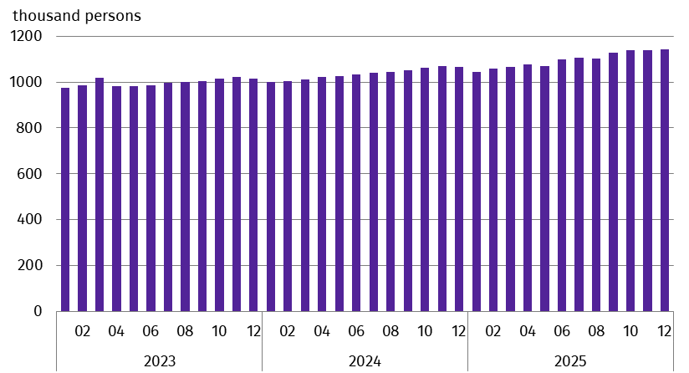
Chart 1. Foreigners performing work
As at the end of a month
At the end of December 2025, there were 17.1% more foreigners performing work than at the end of January 2023
As the size of the population of foreigners performing work increased, so did their share in the total number of persons performing work in Poland – from 6.8% (at the end of December 2024) to 6.9% (at the end of December 2025).

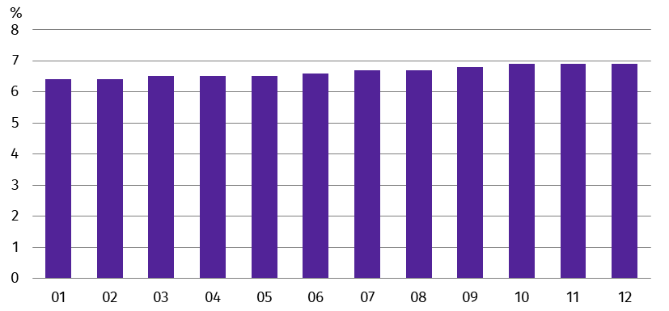
Chart 2. Share of foreigners in the total number of persons performing work in 2025
As at the end of a month
Foreigners performing work by sex
As at 31 December 2025, among the population of foreigners performing work, men constituted the majority – their share was 59.8% ‒ 0.3 percentage points (pp) more than a year before and 0.1 pp more than at the end of November 2025. In individual months of 2025 the sex structure of foreigners performing work did not change significantly. At the end of December 2025, men accounted for 52.6% of Ukrainian citizens performing work, while in the group of foreigners from other countries, the share of men stood at 74.9%.
Foreigners performing work by citizenship
At the end of December 2025, Ukrainian citizens accounted for 67.6% of the total number of foreigners performing work in Poland. As at 31 December 2025, there were 771.8 thousand of them – 8.1% more than on the last day of December 2024 and 0.3% more than in November 2025. The second largest group of foreigners performing work in Poland were Belarusian citizens. As at 31 December 2025, they accounted for 10.4% of the analysed population, i.e. 118.9 thousand. Compared with the last day of December 2024, their number increased by 1.2% and compared with the last day of November 2025, it was 0.6% lower.
In 2025, Ukrainian citizens constituted the vast majority of the analysed population of foreigners
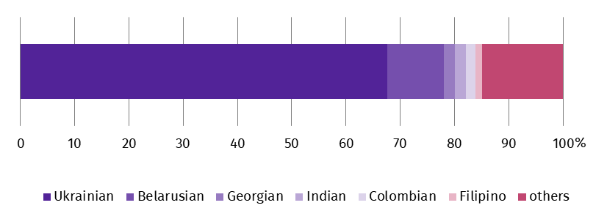
Chart 3. Structure of foreigners performing work by citizenship in December 2025
As at the end of a month
As at 31 December 2025, foreigners performing work in Poland came from over 150 countries

As at 31 December 2025, the number of Colombian citizens performing work compared with the last day of December 2024, increased by 21.3% (by 3.4 thousand). The number of Indian citizens performing work increased by 9.1% (by 1.9 thousand), the number of Ukrainian citizens – by 8.1% (by 57.6 thousand), and the number of Filipino citizens – by 3.2% (by 0.5 thousand). On the other hand, the number of Georgian citizens performing work decreased – by 3.4% (by 0.9 thousand).
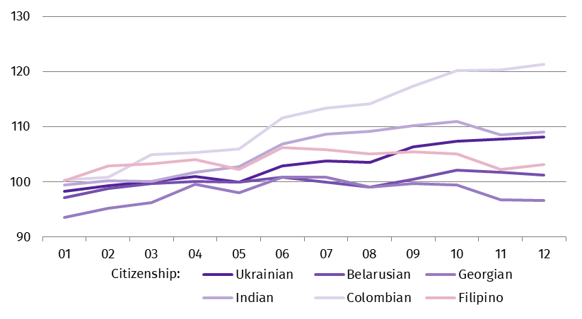
Chart 4. Indices of the number of foreigners performing work in Poland by selected citizenships in 2025
(12.2024 = 100)
Mean age and median age of foreigners performing work
Foreigners performing work as at 31 December 2025, were younger than the corresponding population of Polish citizens. This is indicated by both the mean age and the median age expressed in years. On the last day of December 2025, the mean age of the described group of foreigners was 38.2 against 43.5 of Polish citizens performing work. The relationships expressed by the median age were similar. At the end of December 2025, the median age of foreigners performing work was 37.0 years and was lower than the median age of Polish citizens, which was 43.0 years.
At the end of December 2025, the median age of Ukrainian citizens performing work was 38.0 years
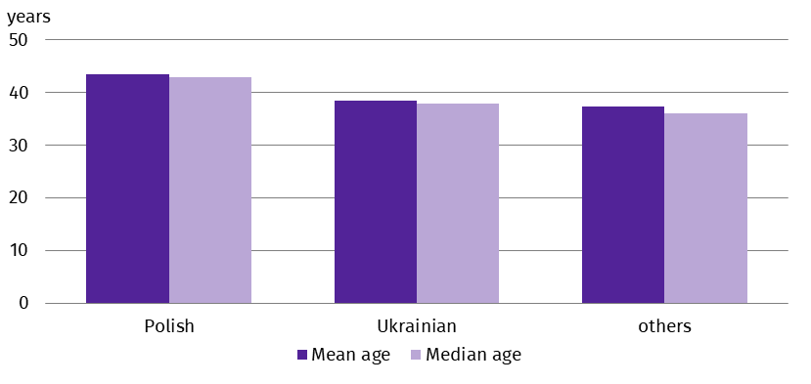
Chart 5. Mean age and median age of persons performing work by citizenship in December 2025
As at the end of a month
Foreigners performing work by place of residence
On the last day of December 2025, every fifth of total number of foreigners performing work lived in the Warszawski stołeczny region (20.3%). On the other hand, the fewest of the analysed population of foreigners lived in the Świętokrzyskie region (0.8%).
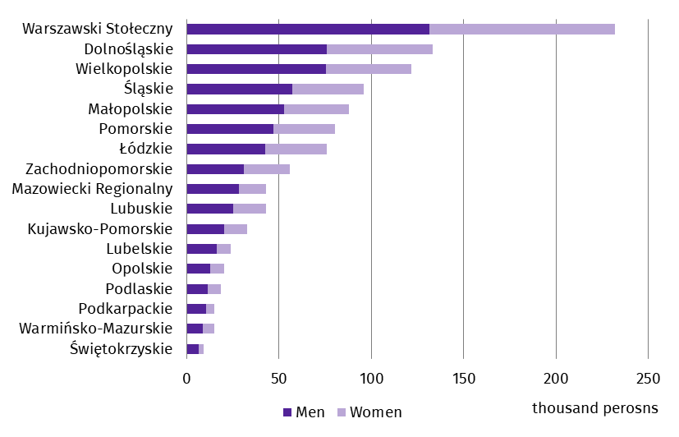
Chart 6. Foreigners performing work by place of residenceª and sex in December 2025
As at the end of a month
At the end of December 2025, the largest number of foreigners performing work lived in the Warszawski stołeczny region
a Data by statistical regions (NUTS 2); excluding foreigners performing work living abroad, i.e. 39.0 thousand
Foreigners performing work by PKD 2007/NACE Rev. 2 section
At the end of December 2025, the relatively largest number of foreigners performing work was recorded in national economy entities operating in section Administrative and support service activities (this section includes, inter alia, the activities of employment agencies providing placement services) – 25.3% persons had citizenship other than Polish (compared with 31 December 2024, an increase of 0.4 pp). In Accommodation and food service activities and Transportation and storage sections, the share of foreigners in the total number of persons performing work was 17.8% and 15.1%, respectively (compared with December 2024, increases of 1.5 pp and 0.7 pp were recorded, respectively). In the remaining sections, their share did not exceed 12.0%, and in three sections it was less than 1.0%.
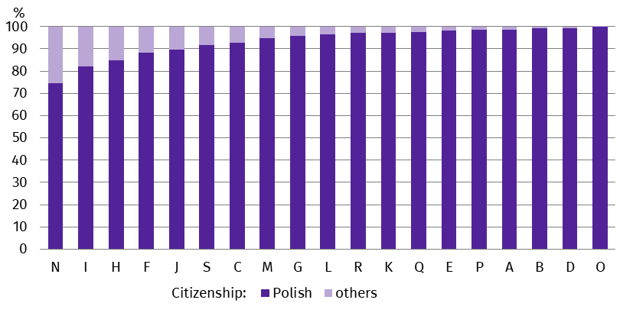
Chart 7. Structure of persons performing work by citizenship and PKD 2007/NACE Rev. 2 section in December 2025
As at the end of a month
At the end of December 2025, more than a quarter of persons performing work in the Administrative and support services activities section were foreigners
On the last day of December 2025, the most foreigners performing work were in the Administrative and support service activities section – 226.9 thousand (compared with 31 December 2024, an increase of 8.3 thousand, i.e. 3.8%), followed by those in the Manufacturing section – 208.3 thousand (an increase of 13.6 thousand, i.e. 7.0%) and in Transportation and storage section – 156.0 thousand (an increase of 6.7 thousand, i.e. 4.5%).
As at 31 December 2025, as in previous observations, in all sections of PKD 2007/NACE Rev. 2, among the total number of foreigners performing work, the most numerous group were Ukrainian citizens.
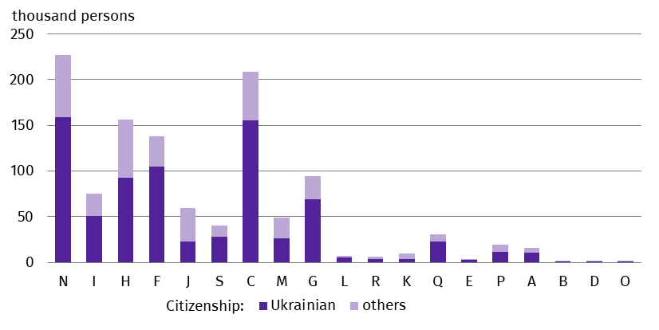
Chart 8. Foreigners performing work by PKD 2007/NACE Rev. 2 section in December 2025
As at the end of a month
Methodological notes
The presented results are part of an experimental study aimed at determining ‒ on the basis of administrative data sources ‒ the number of foreigners performing work. The data presented in the experimental study refer to ‘persons performing work’, i.e. employed persons in the national economy and persons working under contracts of mandate and contracts of a related nature. According to the definition in force in the official statistics system, persons working under civil law contracts are not included in the population of employed persons in the national economy. Contracts of mandate are counted together with contracts of a related nature to which the provisions of the Civil Code apply and which involve the obligation to be covered by social and/or health insurance with the Social Insurance Institution (ZUS), i.e. agency agreements, service contracts, nanny agreements, appointment letters, contracts with members of supervisory boards and managerial contracts having the nature of a contract of mandate. Persons classified as employed who at the same time work under contracts of mandate and related contracts are counted only once and included in the group of employed persons. The analysed population does not include persons working under contracts to perform a specified task and harvest assistance contracts (farmer’s helpers).
Starting from the data for January 2025, the population of persons performing work also includes owners, co-owners and leaseholders of private agricultural holdings (together with contributing family workers).
Symbols of PKD 2007/NACE Rev. 2 sections:
A – Agriculture, forestry and fishing;
B – Mining and quarrying;
C – Manufacturing;
D – Electricity, gas, steam and air conditioning supply;
E – Water supply; sewerage, waste management and remediation activities;
F – Construction;
G – Wholesale and retail trade; repair of motor vehicles and motorcycles;
H – Transportation and storage;
I – Accommodation and food service activities;
J – Information and communication;
K – Financial and insurance activities;
L – Real estate activities;
M – Professional, scientific and technical activities;
N – Administrative and support service activities;
O – Public administration and defence; compulsory social security;
P – Education;
Q – Human health and social work activities;
R – Arts, entertainment and recreation;
S – Other service activities.
Data for section Other service activities (S) also cover people performing work in sections Activities of households as employers; undifferentiated goods- and services-producing activities of households for own use (T) and Activities of extraterritorial organisations and bodies (U).
In the case of quoting Statistics Poland data, please provide information: ‘Source of data: Statistics Poland’, and in the case of publishing calculations made on data published by Statistics Poland, please provide information: ‘Own work based on Statistics Poland data’.
Prepared by:  Statistical Office in Bydgoszcz  Acting Director Katarzyna Klamrowska  Phone: (+48 52) 366 93 90 | Issued by:  Press Office  Mobile phone +48 695 255 032  Landline phones: +48 22 608 38 04, +48 22 449 41 45, +48 22 608 30 09  e-mail: obslugaprasowa@stat.gov.pl

stat.gov.pl/en/

@StatPoland

@GlownyUrzadStatystyczny

@gus_stat

@GłównyUrządStatystycznyGUS

@Glówny Urząd Statystyczny
Related information
Foreigners performing work in Poland in November 2025
Foreigners performing work in Poland in December 2024
Methodological report Employment in the national economy
Terms used in official statistics
Employed persons in the national economy

