Foreigners performing work in Poland in October 2025
At the end of October 2025, the share of foreigners in the total number of persons performing work was 6.9%
On the last day of October 2025, there were 1 139.4 thousand foreigners performing work in Poland, i.e. 7.1% more than in October 2024. Compared with the previous month, their number increased by 0.9%.
1.1 million
number of foreigners performing work in Poland as at 31 October 2025
In the analysed population of foreigners, men constituted the majority – their share was 59.9% ‒ 0.4 percentage points (pp) higher than a year earlier and the same as at the end of September 2025.
Compared with October 2024, the number of both women and men among foreigners performing work increased ‒ by 6.0% and 7.8%, respectively. Compared with 30 September 2025, the number of women increased by 0.8% and the number of men by 1.0%.
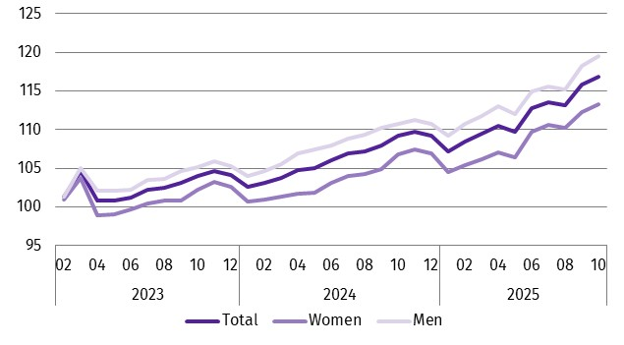
Chart 1. Indices of the number of foreigners performing work in Poland by sex
01 2023 = 100
As at 31 October 2025, among all foreigners performing work, 441.3 thousand persons worked only under contracts of mandate and related contracts. There were 6.3% more of them than in October 2024 and 0.9% more than a month earlier.

Ukrainian citizens were the most numerous group of foreigners performing work in Poland. As at 31 October 2025, there were 767.1 thousand of them, i.e. 7.3% more than in the same month of the previous year and 1.1% more than in September 2025.
Ukrainian citizens accounted for 67.3% of the total number of foreigners performing work in Poland. Their share increased by 0.1 pp compared with the end of October 2024 and by 0.1 pp compared with 30 September 2025.
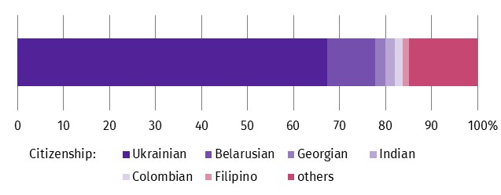
Chart 2. Structure of foreigners performing work in Poland by citizenship in October 2025
As at the end of the month
Foreigners performing work in October 2025 came from over 150 countries
On the last day of October 2025, every fifth foreigner performing work in Poland lived in the Warszawski stołeczny region (20.2%). On the other hand, as in the whole of 2024 and in the previous month, the smallest number of foreigners in the analysed group lived in the Świętokrzyskie region (0.8%).
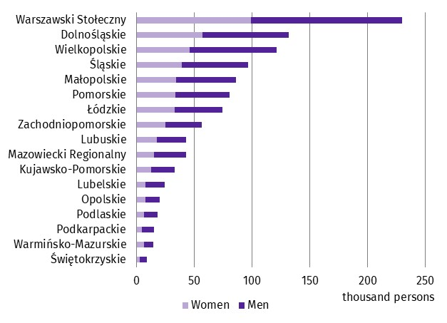
Chart 3. Foreigners performing work in Poland by sex and place of residenceª in October 2025
As at the end of the month
a Data by statistical region (NUTS 2); excluding foreigners living abroad, i.e. 41.1 thousand persons.

Methodological notes
The presented results are part of an experimental study aimed at determining ‒ on the basis of administrative data sources ‒ the number of foreigners performing work. The data presented in the experimental study refer to employed persons in the national economy and persons working under contracts of mandate and contracts of a related nature. According to the definition in force in the official statistics system, persons working under civil law contracts are not included in the population of employed persons in the national economy. Contracts of mandate are counted together with contracts of a related nature to which the provisions of the Civil Code apply and which involve the obligation to be covered by social and/or health insurance with the Social Insurance Institution (ZUS), i.e. agency agreements, service contracts, nanny agreements, appointment letters, contracts with members of supervisory boards and managerial contracts having the nature of a contract of mandate. Persons classified as employed who at the same time work under contracts of mandate and related contracts are counted only once and included in the group of employed persons.
The analysed population does not include persons working under contracts to perform a specified task and harvest assistance contracts (farmer’s helpers).
Starting from the data for January 2025, the population of persons performing work also includes owners, co-owners and leaseholders of private agricultural holdings (together with contributing family workers).
In the case of quoting Statistics Poland data, please provide information: ‘Source of data: Statistics Poland’, and in the case of publishing calculations made on data published by Statistics Poland, please provide information: ‘Own work based on Statistics Poland data’.
Prepared by:  Statistical Office in Bydgoszcz  Acting Director Katarzyna Klamrowska  Phone: (+48 52) 366 93 90 | Issued by:  Press Office  Mobile phone +48 695 255 032  Landline phones: +48 22 608 38 04, +48 22 449 41 45, +48 22 608 30 09  e-mail: obslugaprasowa@stat.gov.pl

www.stat.gov.pl/en/

@StatPoland

@GlownyUrzadStatystyczny

gus_stat

glownyurzadstatystycznygus

glownyurzadstatystyczny
Related information
Experimental study Foreigners performing work in Poland in September 2025
Experimental study Foreigners performing work in Poland in October 2024
Methodological report Employment in the national economy

Terms used in official statistics
Employed persons in the national economy

Starting from the data for January 2025, the population of persons performing work also includes owners, co-owners and leaseholders of private agricultural holdings together with contributing family workers, including foreigners.

