Foreigners performing work in Poland in December 2024
1 064.1 thousand
number of foreigners performing work in Poland as at 31 December 2024
At the end of December 2024, the share of foreigners in the total number of persons performing work in Poland was 6.8%. Between January and December 2024, the number of foreigners performing work increased by 6.4%.
The population of foreigners employed in the national economy and those performing work under civil law contracts in Poland as at the end of December 2024 numbered over 1 million persons.
At the end of December 2024 more than 1 million foreigners were performing work in Poland
The methodology of identification of foreigners performing work applied in this experimental study allows for the presentation of data by sex, age, PKD 2007/NACE Rev. 2 section, citizenship, and at a low level of territorial aggregation, i.e. for powiats and cities with powiat status.
In 2023 and 2024, in general, the number of foreigners performing work who were subject to social insurance under this title was increasing from month to month. At the end of December 2024, the analysed population of foreigners was 1 064.1 thousand. Compared with the last day of January 2024, their number increased by 64.3 thousand, i.e. by 6.4%. Compared with 31 December 2023 it increased by 48.9 thousand persons, i.e. 4.8%. As at the last day of 2024, among the analysed population of foreigners, 414.3 thousand worked under civil law contracts. Compared with January 2024, their number increased by 7.3%, while compared with December 2023, it increased by 4.7%.

Chart 1. Foreigners performing work
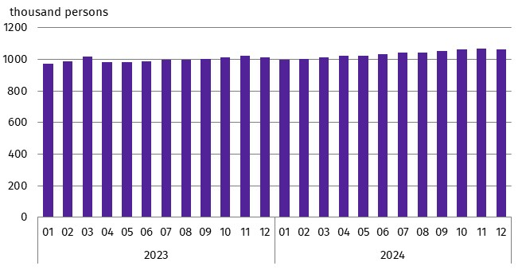
As at the end of a month
At the end of December 2024, there were 9.2% more foreigners performing work than at the end of January 2023
As the size of the population of foreigners performing work increased, so did their share in the total number of persons performing work in Poland – from 6.5% at the end of January 2024 to 6.8% at the end of December 2024.
Chart 2. Share of foreigners in the total number of persons performing work in 2024
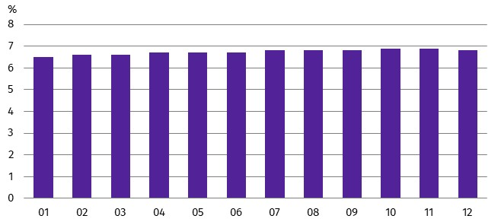
As at the end of a month
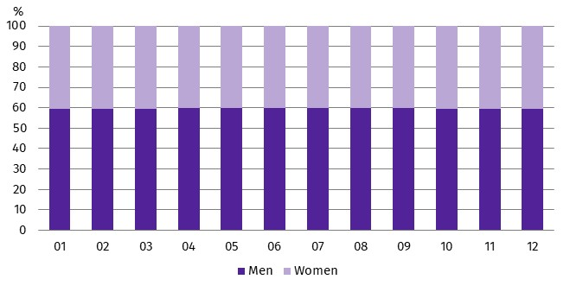
Chart 3. Structure of foreigners performing work by sex in 2024
As at the end of a month
In the analysed group of foreigners, the majority were men. During 2024, their share was approximately 60%. As in the case of all foreigners performing work, men also dominated the sex structure among Ukrainian citizens, although their share was smaller. At the end of January 2024, men accounted for 51.9% of the Ukrainian citizens performing work, while in the group of foreigners coming from other countries the share of men was 75.8%. In the following months of 2024, both in the group of foreigners who were not Ukrainian citizens and among Ukrainian citizens, the sex structure did not change significantly.
The foreigners performing work came from more than 150 countries. In 2024, Ukrainian citizens constituted the vast majority of the analysed population of foreigners. Their share in the total number of foreigners performing work in individual months of 2024 oscillated around 68% (at the end of December 2024 – 67.1%). The second largest group of foreigners performing work in Poland were Belarusian citizens. As at 31 December 2024, they accounted for 11.0% of the analysed population. Citizens of each of the other countries accounted for less than 3% of the total described group of foreigners, but it was among them that the growth rate of the number of persons performing work in 2024 was the highest.
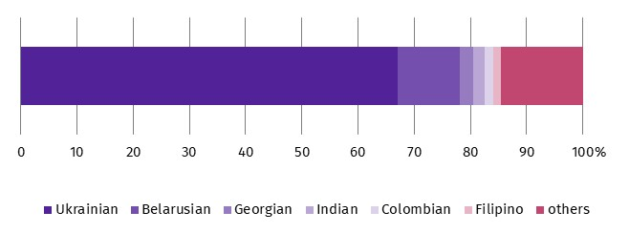
Chart 4. Structure of foreigners performing work by citizenship in 2024
As at 31 December
In 2024, Ukrainian citizens were the most numerous group of foreigners performing work in Poland
As at 31 December 2024, the number of Colombian citizens performing work increased by 200% (by 10.6 thousand persons) compared with January 2024. The number of Filipino citizens increased by 52.0% (by 5.0 thousand persons) and the number of Indian citizens by 12.1% (by 2.3 thousand persons).
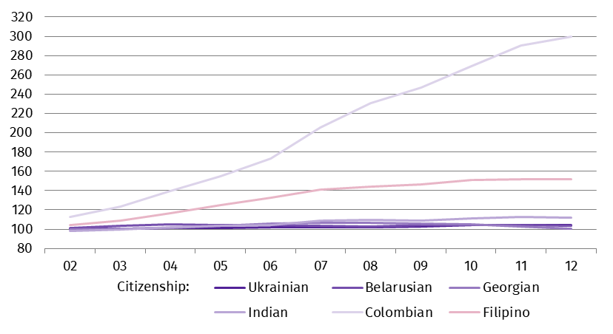
Chart 5. Index of the number of foreigners performing work in Poland by selected citizenships in 2024
(01 2024 = 100)
Foreigners performing work in 2024 were younger than the corresponding population of Polish citizens. This is indicated by both the mean age and the median age. At the end of December 2024, the median age of the described group of foreigners in Poland was lower compared with Polish citizens performing work (38.2 years against 43.0 years). Among foreigners performing work, Ukrainian citizens were, in turn, older than foreigners from other countries. The mean age of Ukrainian citizens of the analysed population was 38.7 years, compared with 37.1 years for other foreigners. The relationships expressed by the median age were similar. At the end of December 2024, the median age of Polish citizens performing work was 42.0 years and was higher than the median age of foreigners, which was 37.0 years. In the described group of foreigners, the median age of Ukrainian citizens was 38.0 years and was 2 years higher than the median age of foreigners from other countries.
At the end of December 2024, the median age of foreigners performing work was 37.0 years
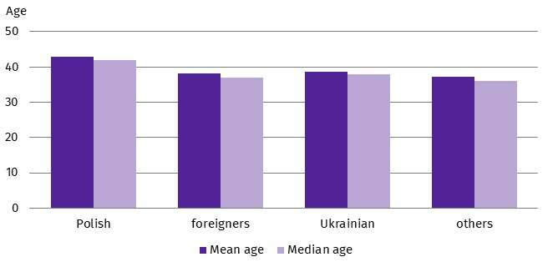
Chart 6. Mean age and median age of persons performing work by citizenship in 2024
As at 31 December
On the last day of December 2024, almost one in five of all foreigners performing work lived in the Warszawski stołeczny region (19.8%). On the other hand, the fewest of the analysed population of foreigners lived in the Świętokrzyskie region (less than 1.0%).
Chart 7. Foreigners performing work by place of residenceª and sex in 2024
At the end of 2024, the largest number of foreigners performing work lived in the Warszawski stołeczny region
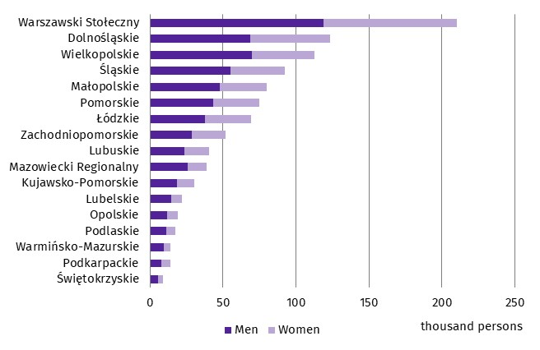
As at 31 December
a Data by statistical regions; excluding foreigners performing work living abroad
Among powiats and cities with powiat status, those from the Lubuskie Voivodship were characterised by a relatively large share of foreigners in the total number of persons performing work.
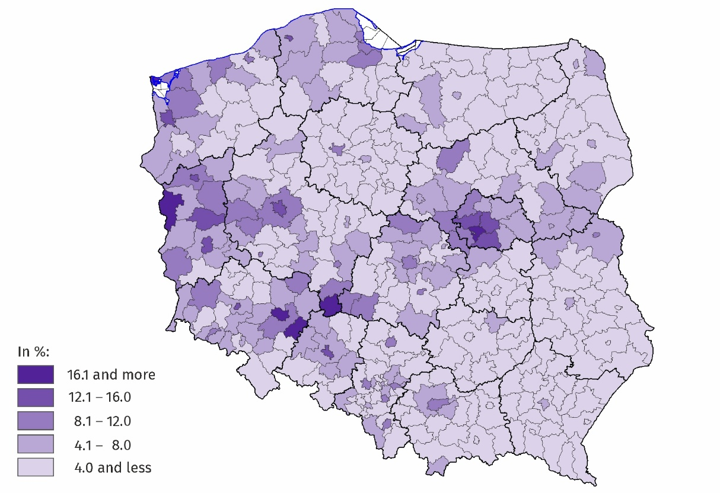
Map 1. Share of foreigners in the total number of persons performing work by place of residence in 2024
As at 31 December
At the end of December 2024, all powiats and cities with powiat status in Poland were inhabited by foreigners performing work
In the majority of powiats and cities with powiat status, Ukrainian citizens predominated among the foreigners performing work who lived there. Their share ranged from 14.5% in the Płocki Powiat to 92.4% in the Bieszczadzki Powiat.
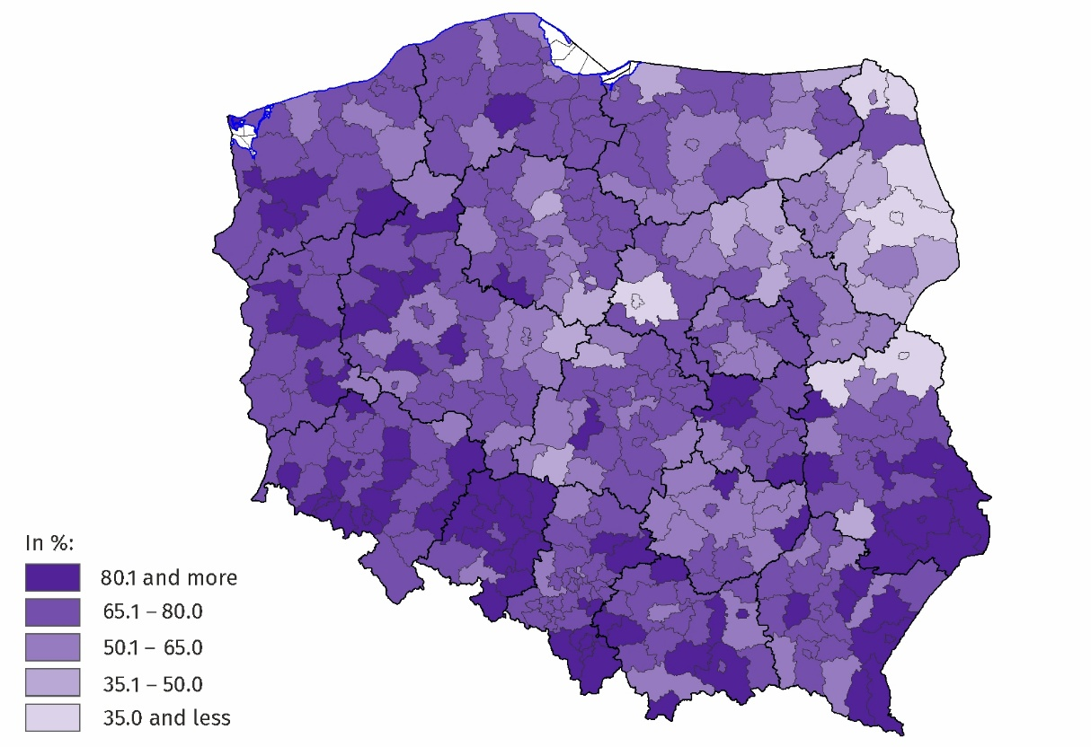
Map 2. Share of Ukrainian citizens in the total number of foreigners performing work by place of residence in 2024
As at 31 December
At the end of December 2024, in 3 powiats, Ukrainian citizens accounted for more than 90% of the foreigners performing work who lived there
At the end of December 2024, the relatively largest number of foreigners performing work was recorded in national economy entities operating in section Administrative and support service activities (this section includes, inter alia, the activities of employment agencies providing placement services) – every fourth person had citizenship other than Polish. In section Accommodation and food service activities and in section Transportation and storage, the share of foreigners in the total number of persons performing work was 16.3% and 14.4%, respectively. In the remaining sections, their share did not exceed 11.0%, and in three sections it was less than 1.0%.
At the end of December 2024, more than a quarter of persons performing work in section Administrative and support services activities were foreigners
The most foreigners performing work were recorded in section Administrative and support service activities – 218.7 thousand persons, followed by section Manufacturing – 194.8 thousand persons, and section Transportation and storage – 149.2 thousand persons.
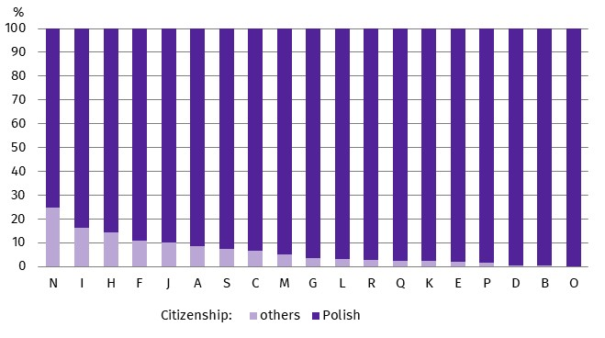
Chart 8. Structure of persons performing work by citizenship and PKD 2007/NACE Rev. 2 section in 2024
As at 31 December
In all sections of PKD 2007 /NACE Rev. 2, among the total number of foreigners performing work, the most numerous group were Ukrainian citizens.
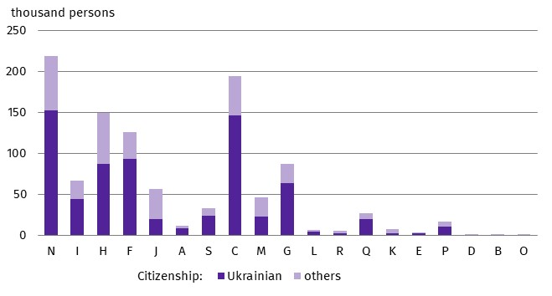
Chart 9. Foreigners performing work by PKD 2007/NACE Rev. 2 section in 2024
As at 31 December

The publication tables contain a wider range of data on foreigners performing work in Poland as at 31 December 2024.

Symbols of PKD 2007/NACE Rev. 2 sections:
A – Agriculture, forestry and fishing;
B – Mining and quarrying;
C – Manufacturing;
D – Electricity, gas, steam and air conditioning supply;
E – Water supply; sewerage, waste management and remediation activities;
F – Construction;
G – Wholesale and retail trade; repair of motor vehicles and motorcycles;
H – Transportation and storage;
I – Accommodation and food service activities;
J – Information and communication;
K – Financial and insurance activities;
L – Real estate activities;
M – Professional, scientific and technical activities;
N – Administrative and support service activities;
O – Public administration and defence; compulsory social security;
P – Education;
Q – Human health and social work activities;
R – Arts, entertainment and recreation;
S – Other service activities.
Data for section Other service activities (S) also cover persons performing work in sections Activities of households as employers; undifferentiated goods- and services-producing activities of households for own use (T) and Activities of extraterritorial organisations and bodies (U).
In the case of quoting Statistics Poland data, please provide information: ‘Source of data: Statistics Poland’, and in the case of publishing calculations made on data published by Statistics Poland, please provide information: ‘Own work based on Statistics Poland data’.
Prepared by:  Statistical Office in Bydgoszcz  Director Wiesława Gierańczyk, Ph.D.  Phone: (+48 52) 366 93 90 | Issued by:  Press Office  Mobile phone +48 695 255 032  Landline phones: +48 22 608 38 04, +48 22 449 41 45, +48 22 608 30 09  e-mail: obslugaprasowa@stat.gov.pl

www.stat.gov.pl/en/

@StatPoland

@GlownyUrzadStatystyczny

gus_stat

glownyurzadstatystycznygus

glownyurzadstatystyczny
Related information
Foreigners performing work in Poland in 2023
Methodological report Employment in the national economy
Methodological report Employment in the national economy according to administrative data sources
Terms used in official statistics
Median age
Employment in national economy

The information presented here is part of experimental work to determine, based on administrative sources, the number of foreigners performing work. According to the definition in force in the official statistics system, persons working under civil law contracts are not included in the population of employed persons in the national economy. However, the data presented in the experimental study refer to ‘persons performing work’, i.e. employed persons in the national economy and persons working under civil law contracts identifiable in administrative records. Persons classified as employed who at the same time work under civil law contracts are counted only once and included in the group of employed persons. The analysed population does not include owners, co-owners and leaseholders of individual agricultural holdings (including contributing family workers), as well as persons working under contracts to perform a specified task and farmer's helpers.

