Foreigners performing work in Poland in January 2023
At the end of January 2023, the share of foreigners in the total number of people performing work was 6.4%. Foreigners performing work in January 2023 came from over 150 countries.
974.5 thousand
number of foreigners performing work in Poland as at 31 January 2023

At the end of January 2023, there were 974.5 thousand foreigners performing work, of which 407.8 thousand were foreigners working under civil law contracts.
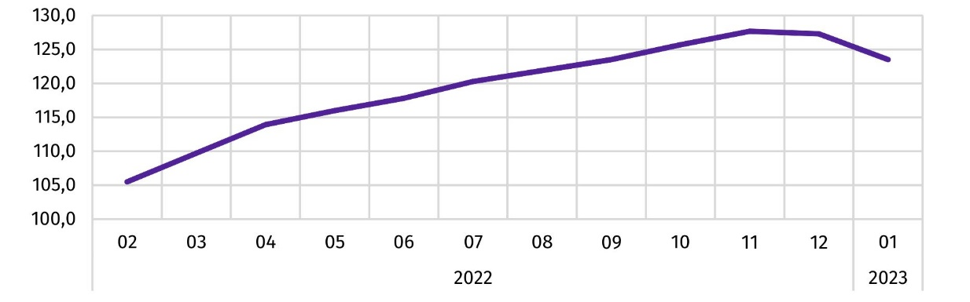
Chart 1. Dynamics of the number of foreigners performing work in Poland
(01 2022 = 100)
The share of foreigners performing work in Poland in the total number of people performing work in Poland increased by 1.2 percentage points compared with January 2022

In the analysed population of foreigners, the majority were men, their share decreased from 64.7% at the end of January 2022 to 58.6% at the end of January 2023.
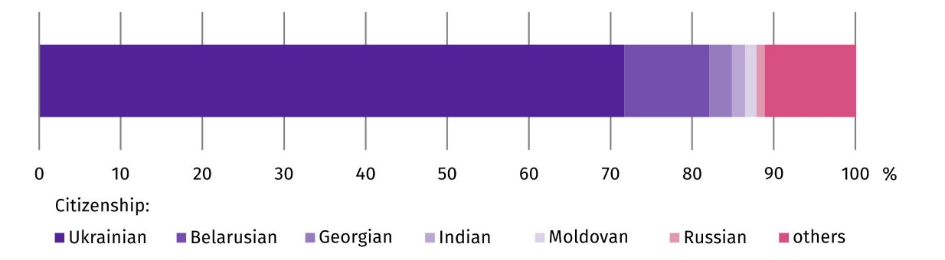
Chart 2. Structure of foreigners performing work by citizenship in 2023
As at 31 January

The most numerous group of foreigners performing work in Poland were citizens of Ukraine, who numbered 697.7 thousand at the end of January 2023. Their share in the total number of foreigners performing work decreased by 1.7 percentage points compared with January 2022.

Methodological notes
The presented results are part of an experimental study aimed at determining the number of foreigners performing work on the basis of administrative data sources. According to the definition in force in official statistics, persons working under civil law contracts are not included in the population of employed persons in the national economy. However, the data presented in the experimental study concern ‘persons performing work’, i.e. employed persons in the national economy and persons working under civil law contracts identifiable in administrative records. Persons classified as employed who at the same time work under civil law contracts are counted only once and included in the group of employed persons. The analysed population does not include owners, co-owners and leaseholders of individual agricultural holdings (including contributing family workers), as well as persons working under contracts to perform a specified task and farmer's helpers.

In the case of quoting Statistics Poland data, please provide information: ‘Source of data: Statistics Poland’, and in the case of publishing calculations made on data published by Statistics Poland, please provide information: ‘Own elaboration based on Statistics Poland data.’
Prepared by:  Statistical Office in Bydgoszcz  Director Wiesława Gierańczyk, Ph.D.  Phone: (+48 52) 366 93 90 | Issued by:  The Spokesperson for the President  of Statistics Poland  Karolina Banaszek  Phone: (+48) 695 255 011
Press Office  Phone: (+48 22) 608 38 04  e-mail: obslugaprasowa@stat.gov.pl |   stat.gov.pl/en/

@GUS_STAT

@GlownyUrzadStatystyczny

gus_stat

glownyurzadstatystycznygus

glownyurzadstatystyczny
Related information
Methodological report Employment in the national economy
Methodological report Employment in the national economy according to administrative data sources
Terms used in official statistics
Employment in national economy

