Foreigners performing work in Poland in 2023
1 015.1 thousand
number of foreigners performing work in Poland as at 31 December 2023
At the end of December 2023, the share of foreigners in the total number of people performing work in Poland was 6.6%. Between January and December 2023, the number of foreigners performing work increased by 4.2%.
Introduction
The study analyses the population of foreigners employed in the national economy and working under civil law contracts in Poland in 2023 by sex and age, PKD/NACE section, citizenship and in territorial breakdowns. The studied population as at the end of December 2023 numbered over 1 million people.
The complexity and changeability of the situation in the Polish labour market entail the need for new and more detailed data on labour resources, including foreigners performing work in Poland. The demand for information on foreigners in the labour market increased, inter alia, after the Russian invasion of Ukraine, when the inflow of foreigners to Poland increased. In order to meet the new information needs, an attempt was made – as part of experimental statistics – to determine the number of foreigners in the labour market on the basis of administrative sources. The methodology used in this experimental study for the identification of foreigners performing work makes it possible to present data from January 2022 at a monthly frequency, including a breakdown by sex, and at a low level of territorial aggregation, i.e. in powiats and cities with powiat status.
At the end of December 2023 more than 1 million foreigners were performing work in Poland
Foreigners performing work
In 2022 and 2023, in principle, the number of foreigners performing work who were subject to social insurance under this title was increasing from month to month. At the end of December 2023, the analysed population of foreigners amounted to 1 015.1 thousand, compared with the last day of January 2023, their number increased by 40.7 thousand, i.e. by 4.2%. As at the last day of 2023, among the analysed population of foreigners, 395.6 thousand people worked under civil law contracts. Compared with January 2023, their number decreased by 3.0%.
Chart 1. Foreigners performing work
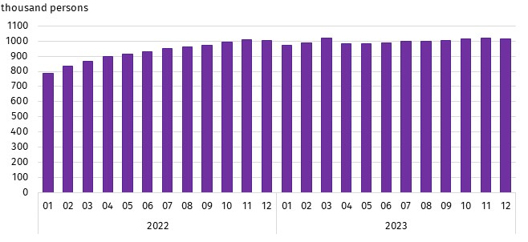
As at the end of the month
At the end of December 2023, there were 4.2% more foreigners performing work than at the end of January 2023
As the size of the population of foreigners performing work increased, so did their share in the total number of people performing work in Poland – from 6.4% at the end of January 2023 to 6.6% at the end of December 2023.
Chart 2. Share of foreigners in the total number of people performing work in 2023
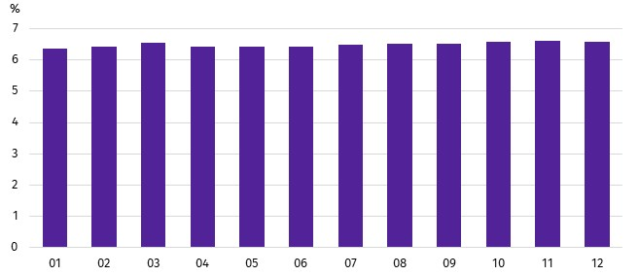
As at the end of the month
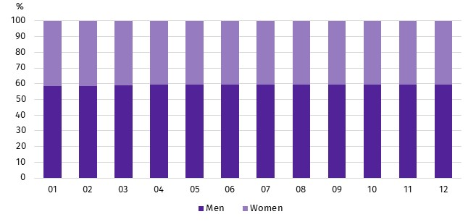
Chart 3. Structure of foreigners performing work by sex in 2023
As at the end of the month
Among foreigners, the majority were men. In 2023, their share increased from 58.6% at the end of January to 59.2% at the end of December. As in the case of all foreigners performing work, men also dominated the sex structure among Ukrainian citizens, although their share was lower. At the end of January 2023, men accounted for 51.6% of Ukrainian citizens performing work. In the remaining group of foreigners, men accounted for 75.8%. In the following months of 2023, both in the group of foreigners who were not Ukrainian citizens and among Ukrainian citizens, the sex structure did not change significantly.
The foreigners performing work came from more than 150 countries. In 2023, Ukrainian citizens constituted the vast majority of the analysed population of foreigners. Their share in the total number of foreigners performing work in individual months of 2023 oscillated around 69%. The second largest group of foreigners performing work in Poland were Belarusian citizens. As at 31 December 2023, they accounted for 11.5% of the analysed population. Citizens of each of the other countries accounted for less than 3% of the total described group of foreigners, but it was among them that the increase in the number of those performing work in 2023 was the largest.
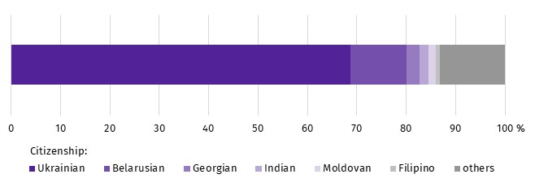
Chart 4. Structure of foreigners performing work by citizenship in 2023
As at 31 December
In 2023, Ukrainian citizens were the most numerous group of foreigners performing work in Poland
During this period, the number of Filipino citizens performing work increased by nearly 40% (2.7 thousand persons), among Indian citizens by more than 23% (3.6 thousand persons) and among Belarusian citizens by 14.7% (14.9 thousand persons). In the analysed year, there was essentially no change in the number of Ukrainian citizens performing work.
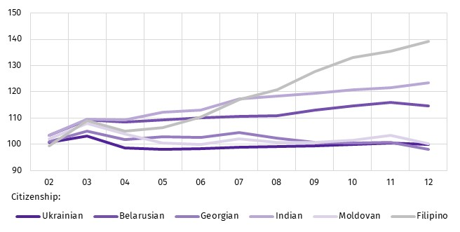
Chart 5. Dynamics of the number of foreigners performing work in Poland by selected citizenships in 2023
(01 2023 = 100)

Foreigners performing work in 2023 were younger than the corresponding population of Polish citizens. This is indicated by both the mean and median age. At the end of December 2023, the mean age of the described group of foreigners in Poland was lower compared with Polish citizens performing work (37.8 years against 42.8 years). Among foreigners performing work, Ukrainian citizens were, in turn, older than foreigners from other countries. The mean age of Ukrainian citizens of the analysed population was 38.2 years compared with 36.8 years for other foreigners. Relationships expressed by the median age were similar. At the end of December 2023, the median age of Polish citizens performing work was 42.0 years and was higher than the median age of foreigners, which was 37.0 years. In the described group of foreigners, the median age of Ukrainian citizens was 38.0 years and was 3 years higher than the median age of foreigners from other countries.
At the end of December 2023, the median age of foreigners performing work was 37.0 years
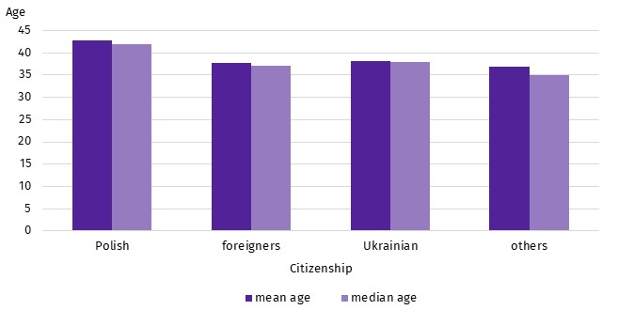
Chart 6. Mean age and median age of people performing work by citizenship in 2023
As at 31 December
On the last day of December 2023, one in five of the total number of foreigners performing work lived in the Warszawski stołeczny region (19.1%). On the other hand, the smallest number of foreigners among the analysed population lived in the Świętokrzyskie region (less than 1.0%).
Chart 7. Foreigners performing work by place of residenceª and sex in 2023
At the end of 2023, the largest number of foreigners performing work lived in the Warszawski stołeczny region
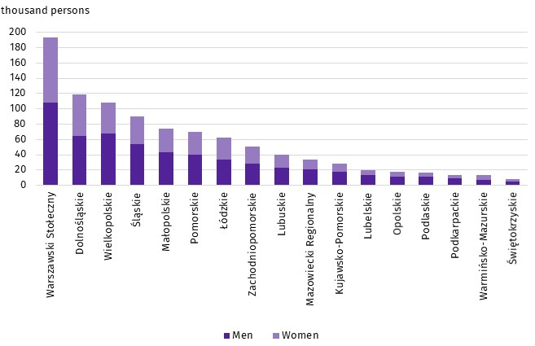
As at 31 December
a Data by statistical regions; excluding foreigners performing work living abroad
Among powiats and cities with powiat status, those from the Lubuskie Voivodship were characterised by a relatively high share of foreigners in the total number of people performing work.
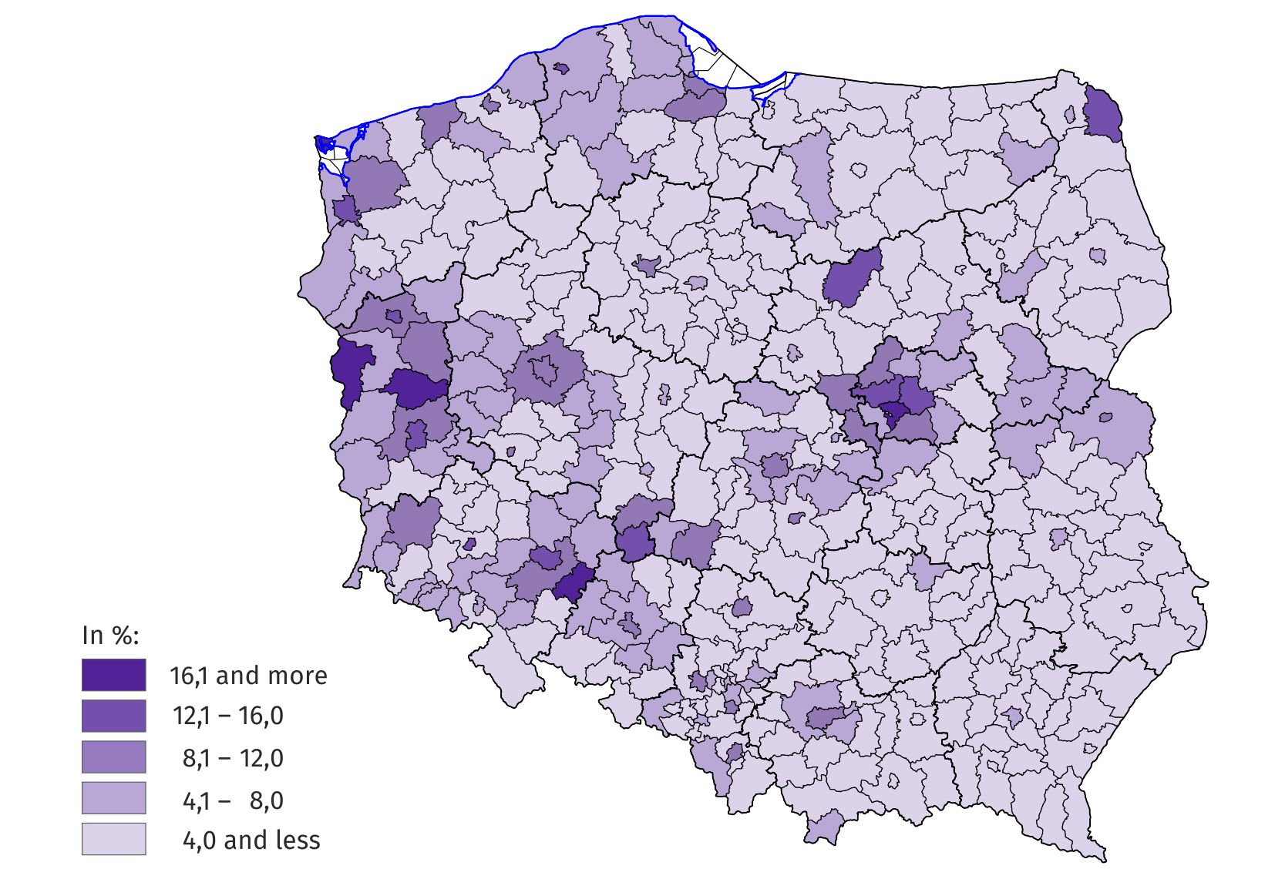
Map 1. Share of foreigners in the total number of people performing work in the powiats and cities with powiat status of residence in 2023
As at 31 December
As at the end of December 2023, all powiats and cities with powiat status were inhabited by foreigners performing work
In the majority of powiats and cities with powiat status, Ukrainian citizens prevailed among the foreigners living there and performing work. Their share ranged from 94.8% in the Bieszczadzki Powiat in the Podkarpackie Voivodship to 17.0% in the city of Biała Podlaska – a city with powiat status in the Lubelskie Voivodship.
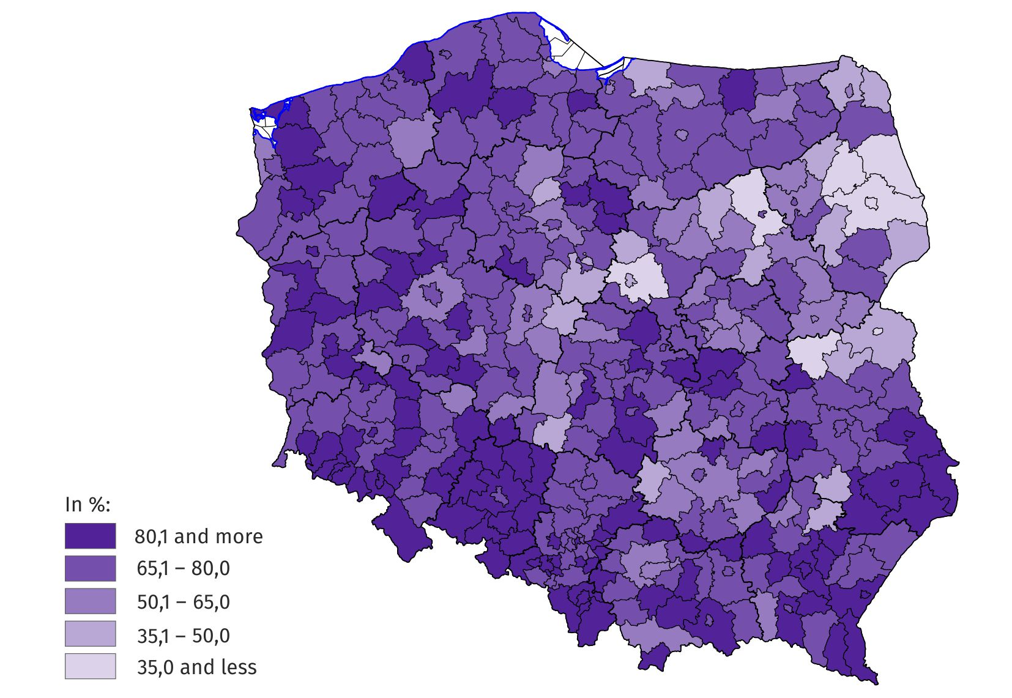
Map 2. Share of Ukrainian citizens in the total number of foreigners performing work in the powiats and cities with powiat status of residence in 2023
As at 31 December
At the end of December 2023, in 5 powiats and cities with powiat status, Ukrainian citizens accounted for more than 90% of the foreigners living there and performing work
At the end of December 2023, the relatively largest number of foreigners performing work was recorded in national economy entities operating in the Administrative and support service activities section (this section includes, inter alia, the activities of employment agencies providing placement services) – every fourth person had citizenship other than Polish. In the Accommodation and food service activities section and in the Transportation and storage section, the share of foreigners in the total number of people performing work was 15.4% and 14.3% respectively. In the remaining sections, their share did not exceed 11%, and in three sections it was less than 1.0%.
At the end of December 2023, more than a quarter of people performing work in the Administrative and support services activities section were foreigners
In terms of the number of foreigners performing work, the Administrative and support service activities section was ranked first – with 217.7 thousand foreigners. Approximately 38 thousand fewer foreigners were in the Manufacturing section and about 68 thousand fewer in the Transportation and storage section.
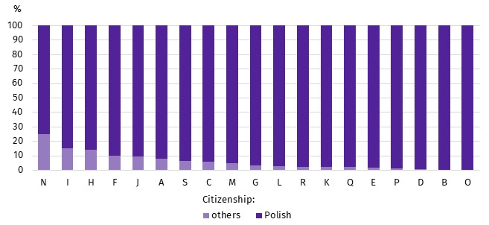
Chart 8. Structure of people performing work by citizenship and PKD/NACE section in 2023
As at 31 December
In almost all PKD/NACE sections, Ukrainian citizens were the most numerous group among all foreigners performing work. The exception was the Information and communication section, where Belarusian citizens prevailed.
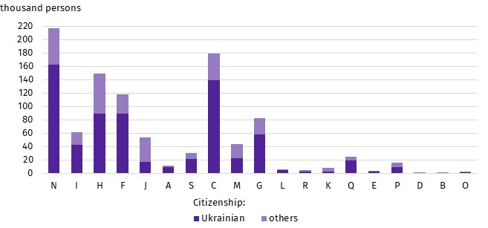
Chart 9. Foreigners performing work by PKD/NACE section in 2023
As at 31 December

PKD/NACE sections:
A – Agriculture, forestry and fishing
B – Mining and quarrying;
C – Manufacturing;
D – Electricity, gas, steam and air conditioning supply;
E – Water supply; sewerage, waste management and remediation activities;
F – Construction;
G – Wholesale and retail trade; repair of motor vehicles and motorcycles;
H – Transportation and storage;
I – Accommodation and food service activities;
J – Information and communication;
K – Financial and insurance activities;
L – Real estate activities;
M – Professional, scientific and technical activities;
N – Administrative and support service activities;
O – Public administration and defence; compulsory social security;
P – Education;
Q – Human health and social work activities;
R – Arts, entertainment and recreation;
S – Other service activities.
When quoting Statistics Poland data, please provide the information: “Source of data: Statistics Poland”, and when publishing calculations made on data published by Statistics Poland, please include the following disclaimer: “Own study based on figures from Statistics Poland”.
Prepared by:  Statistical Office in Bydgoszcz  Director Wiesława Gierańczyk, Ph.D.  Phone: (+48 52) 366 93 90 | Issued by:  Press Office  Mobile phone: +48 695 255 032  Landline phones: +48 22 608 38 04, +48 22 449 41 45, +48 22 608 30 09  e-mail: obslugaprasowa@stat.gov.pl

stat.gov.pl/en/

@StatPoland

@GlownyUrzadStatystyczny

gus_stat

glownyurzadstatystycznygus

glownyurzadstatystyczny
Related information
Foreigners performing work in Poland in 2022
Methodological report Employment in the national economy
Methodological report Employment in the national economy according to administrative data sources
Terms used in official statistics
Median age
Employment in national economy

The results presented here are part of experimental work to determine, based on administrative sources, the number of foreigners performing work. According to the definition in force in the official statistics system, persons working under civil law contracts are not included in the population of employed persons in the national economy. However, the data presented in the experimental study refer to ‘persons performing work’, i.e. employed persons in the national economy and persons working under civil law contracts identifiable in administrative records. Persons classified as employed who at the same time work under civil law contracts are counted only once and included in the group of employed persons. The analysed population does not include owners, co-owners and leaseholders of individual agricultural holdings (including contributing family workers), as well as persons working under contracts to perform a specified task and farmer's helpers.

