Foreigners performing work in Poland in September 2024
At the end of September 2024, the share of foreigners in the total number of people performing work was 6.8%. Foreigners performing work in September 2024 came from over 150 countries.
1 052.7 thousand
number of foreigners performing work in Poland as at 30 September 2024
At the end of September 2024, there were 1 052.7 thousand foreigners performing work in Poland. This number includes 407.4 thousand foreigners working under contracts of mandate and related contracts.
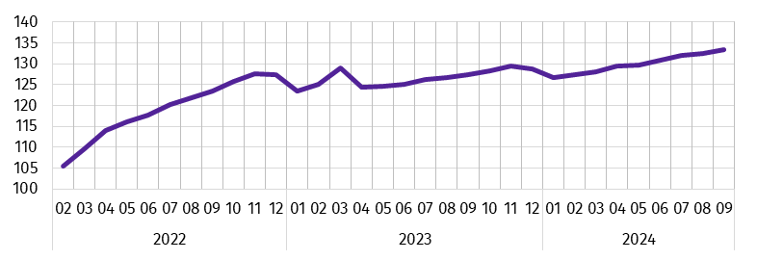
Chart 1. Dynamics of the number of foreigners performing work in Poland
(01 2022 = 100)
The share of foreigners performing work in Poland in the total number of people performing work in Poland increased by 1.6 percentage points compared with January 2022
In the analysed population of foreigners, the majority were men, their share decreased from 64.7% at the end of January 2022 to 59.8% at the end of September 2024.
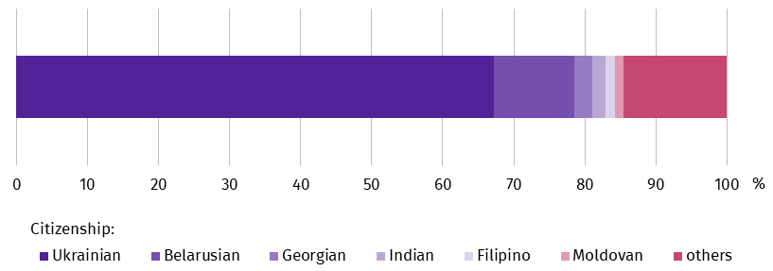
Chart 2. Structure of foreigners performing work by citizenship in 2024
As at 30 September

The most numerous group of foreigners performing work in Poland were citizens of Ukraine, who numbered 707.9 thousand at the end of September 2024. Their share in the total number of foreigners performing work was 67.2%, down 6.1 percentage points compared with January 2022.
On the last day of September 2024, almost one in five of all foreigners performing work lived in the Warszawski stołeczny region (19.4%). On the other hand, the smallest number of foreigners among the analysed population lived in the Świętokrzyskie region (less than 1.0%).
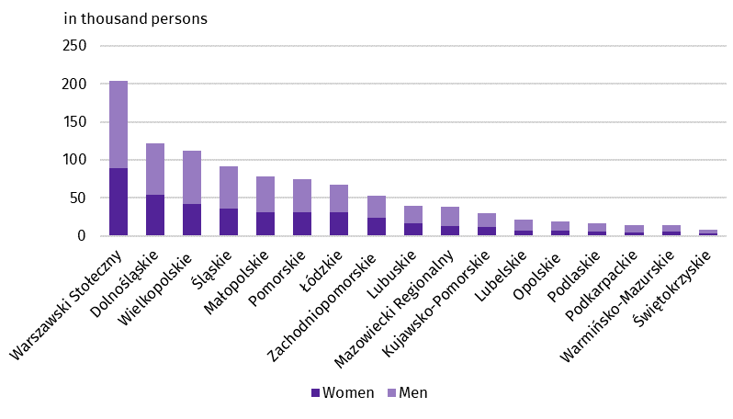
Chart 3. Foreigners performing work by sex and place of residenceª in 2024
As at 30 September
a Data by statistical regions; excluding foreigners performing work living abroad.
Methodological notes
The presented results are part of an experimental study aimed at determining the number of foreigners performing work on the basis of administrative data sources. According to the definition in force in the official statistics system, persons working under civil law contracts are not included in the population of employed persons in the national economy. However, the data presented in the experimental study concern ‘persons performing work’, i.e. employed persons in the national economy and persons working under contracts of mandate and related contracts. Contracts of mandate are counted together with contracts of a related nature to which the provisions of the Civil Code apply and which involve the obligation to be covered by social and/or health insurance at the Social Insurance Institution (ZUS), i.e. agency agreements, service contracts, activation agreements, appointment letters, contracts with members of supervisory boards and managerial contracts having the nature of a contract of mandate. Persons classified as employed who at the same time work under contracts of mandate and related contracts are counted only once and included in the group of employed persons. The analysed population does not include owners, co-owners and leaseholders of individual agricultural holdings (including contributing family workers), as well as persons working under contracts to perform a specified task and farmer’s helpers.
In the case of quoting Statistics Poland data, please provide information: ‘Source of data: Statistics Poland’, and in the case of publishing calculations made on data published by Statistics Poland, please provide information: ‘Own work based on Statistics Poland data”.
Prepared by:  Statistical Office in Bydgoszcz  Director Wiesława Gierańczyk, Ph.D.  Phone: (+48 52) 366 93 90 | Issued by:  Press Office  Mobile phone +48 695 255 032  Landline phones: +48 22 608 38 04, +48 22 449 41 45, +48 22 608 30 09  e-mail: obslugaprasowa@stat.gov.pl

www.stat.gov.pl/en/

@StatPoland

@GlownyUrzadStatystyczny

gus_stat

glownyurzadstatystycznygus

glownyurzadstatystyczny
Related information
Experimental study Foreigners performing work in Poland in 2023
Methodological report Employment in the national economy
Methodological report Employment in the national economy according to administrative data sources
Terms used in official statistics
Employed persons in the national economy

